Coming Up Golden
Renovations, new business and the Hygienic Art Park revitalize a downtown street
By DAVID COLLINS
Day Staff Columnist, Features
Published on 12/12/2005

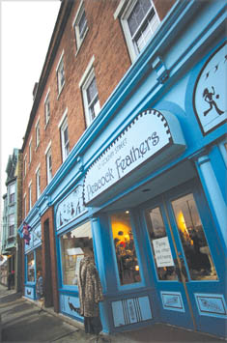
Buy this Photo | Tim Martin
Peacock Feathers, a new business located on Golden Street in New London, in a newly remodeled 19th-century building owned by Brendan and Frank McLaughlin.

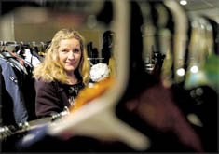
Buy this Photo | Tim Martin
Betty Latham, owner of Peacock Feathers.

When Betty Latham began to look for a space in downtown New London in which to open a second-hand clothing shop, she was surprised, given the number of empty storefronts, how hard it was to find something.
“It seems like (the landlords) are all from New York and they all want a lot of money,” she says. “This isn't Mystic, where you can sell enough to pay $2,000 to $3,000 in rent. Forget about it.”
Then Latham met the McLaughlin’s, a father-and-son team who are remodeling a 19th-century building on Golden Street.
The three forged an alliance and worked out a sliding rent schedule, very little in the beginning years, then more later on, as the business, and downtown redevelopment, gain momentum.
“It does two things. It gets her into the building at a reasonable rent. And it gets the building occupied, with some cash flow,” says Brendan McLaughlin, who owns the building with his father, Frank McLaughlin. “It's kind of a win-win for everyone.”
With the deal sealed, Lynda Wesley McLaughlin, Frank's wife and Brendan's mother, who is an artist, set to work painting the façade at 13 Golden St. a peacock blue, to complement Latham's business, which is called Peacock Feathers. Along the top of the storefront are a series of figures in silhouette, which give passersby the impression of the busy place this little stretch of Golden Street, bordered on one side by the new Hygienic Art Park, seems to have become.
The result of this combination of skills, goodwill and ambition is, everyone involved says, shaping up as a downtown success story.
Latham, who has closed her antiques business in Pawcatuck to concentrate on the New London store, is already getting a lot of traffic. Peacock Feathers concentrates on old clothing, items Latham hand selects from estates and other sources she has cultivated over the years, but there's also an eclectic mix of old glassware, jewelry, art and artifacts.
She says she has already developed a regular clientele, many of them Connecticut College students and faculty. On nights when there are events at the Hygienic, she stays open later.
The McLaughlin’s say they are already seeing some interest in the four three-bedroom apartments they are creating on the top two floors of the brick building they have gutted. The new apartments will have air conditioning, wood floors, tile bathrooms, exposed brick walls, some side views of the Thames River and a common roof deck. The first one is expected to be ready in about a month.
Brendan McLaughlin said most of the projects he's done with his father, a real estate broker, have been two- and three-family houses in the city. They were looking for something bigger, downtown, and were drawn to the Golden Street building because of its proximity to the municipal parking lots and the new art park. They bought it last spring for $285,000. The front windows of the apartments, which will rent in the range of $1,200 to $1,400, all face the park.
“We think we can attract empty nesters and couples without children, people who want a nice space and would pay a little more for it,” says McLaughlin, who uses the term upscale rather than luxury when describing the new apartments.
“There are a huge number of people right now pushing for New London to become one of the more popular destinations on the eastern Connecticut shoreline,” he says. “There's a demand for housing now. If you price it right you'll rent it.”
Latham says she's enjoyed a new sense of community that seems to be developing among the business owners downtown, who see each other more as collaborators than competitors.
“We need to give people a reason to come to New London,” she says. “Everyone is being supportive and helpful, which is nice in a community. Small businesses are what makes a place special. There are a lot of cute and interesting shops here.
“New London is up and coming.”

