Family Restoring City Buildings — And Pride
Union Street enclave is latest in a series of New London projects
By Elaine Stoll
Click name for author info, most recent articles ...
Published on 5/29/2006 in Region » Region News

New London -- Three boarded-up houses and a burned-out apartment building stand in a cluster of neglect downtown where Union and Pearl streets meet.

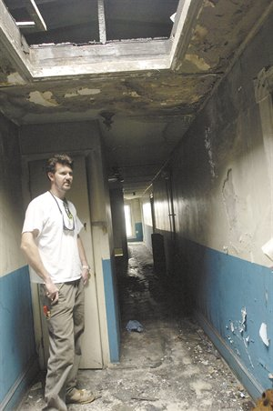
Buy Photo |  | by Tim Martin

Brendan McLaughlin shows the fire-damaged condition Friday of a property at 2 Union St. in New London. McLaughlin's father's company is planning to renovate the building and three others in the city and turn them into apartments.
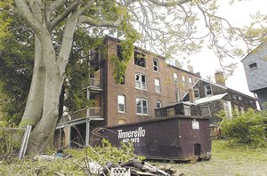
by Jessica Wurm

A trash container sits beside one of the properties Frank McLaughlin and his son, Brendan, hope to renovate and turn into apartments.

“No Trespassing” signs, overgrown grass and a discarded couch greet passersby, but it takes a tour to tell how far the housing is from habitable. So Frank McLaughlin, 64, and his 36-year-old son, Brendan McLaughlin, led one the other day.
The red brick apartment complex at 2 Union St. was built in 1895 and condemned after a fatal 2004 fire. Walls with peeling paint and exposed wires divide the strewn clothes, furniture and other effects of former occupants on the first floors. A gaping hole in the roof lets the sunlight shine through the top floor, where the fire left little more than ash, rubble and shattered glass from blown-out windows.
The McLaughlins could hardly believe their visitors declined a tour of the other three promising properties –– the 1840s-era houses at 4, 6 and 12 Union Court –– which they just bought this month along with the apartment complex for $330,000.
“The insides of those houses are really nasty. The floors are sagging. The middle one is more work than we thought,” Frank McLaughlin said.
He and his son, founder and managing partner, respectively, of New London-based McLaughlin Companies LLC, are eager to turn the four buildings into 16 apartment units. The rehabilitation project will cost between $900,000 and $1 million on top of the purchase price and will take a year-and-a-half to two years to finish, they said.
For the first 10 years after the rehab, the apartments will be leased at or below rent rates determined by the U.S. Department of Housing and Urban Development under a financing agreement the McLaughlins have with The Dime Bank. Dime's CHAMP program –– Creating Housing Affordable Mortgage Program –– offers experienced landlords below-market interest rates and other incentives to renovate vacant properties in southeastern Connecticut.
“You fix this up, it will be a nice little corner of New London,” John J. Dolan, vice president of commercial lending at The Dime Bank, said after taking the McLaughlins' tour last week.
The properties on Union Street and Union Court won't be the first corner of New London that McLaughlin Companies has tackled.
The family business, which also includes Frank McLaughlin's wife, Lynda McLaughlin, 60, as secretary/treasurer and his 30-year-old daughter, Stephanie McLaughlin Neal, current bookkeeper and future co-owner, now owns about 19 buildings totaling 65 apartment units.
Frank McLaughlin founded McLaughlin Companies, located on Williams Street, about five years ago. For many years, he lived in St. Thomas in the U.S. Virgin Islands, turning McLaughlin Realtors into the largest real estate company there.
He and his wife, who is from Groton, decided to move full time to their second home in Mystic after experiencing Hurricane Marilyn in 1995 and Hurricane Hugo in 1989. McLaughlin divided his St. Thomas business into four and sold them separately.
In Connecticut, “I thought I was going to retire, but I like to keep busy,” he said.
Frank McLaughlin started a company called BMW, then bought out his partners and incorporated that business into the new McLaughlin Companies. Brendan McLaughlin, who now lives in New London, joined his father about three years ago after successfully running one of the off-shoot businesses in St. Thomas.
McLaughlin Companies started out buying rental properties in relatively good shape. When the company undertook its first complete renovation, of the three-family house at 16 Montauk Ave., it found its niche.
“That was a boarded-up, condemned property,” Brendan McLaughlin said. “We started working with the city and we realized they are excited about bringing derelict properties back online.”
•••Most of the company's projects have been rehabilitations of two- to six- family houses, though the McLaughlins are also renovating a mixed-use commercial and residential building at 13 Golden St. They bought the property for $285,000 and have finished a first-floor commercial space now occupied by Peacock Feathers.
They are gutting and reframing the second- and third-floor apartments, last occupied in 1974. The result will be four three-bedroom, two-bathroom apartments with wood floors, exposed brick and trusses and partial views of the Thames River. The first unit will be ready in as soon as six weeks, and the other three will be finished every third week after that, Frank McLaughlin said. All told, they are spending $300,000 in addition to the purchase price.
McLaughlin Companies just signed a contract to buy the Soltz Meat Market building, also on Golden Street, which will be rented to a commercial tenant.
All of the McLaughlin Companies' projects have been in New London, and Frank and Brendan McLaughlin said they don't expect that to change any time soon.
“There are opportunities in Norwich and opportunities in Montville. But every time we're ready to do a new project, we look first in New London, and we've always found deals in New London,” Frank McLaughlin said.
“I've definitely seen some improvements to the downtown area in the three years since I've been here,” Brendan McLaughlin said. “I've watched the property values go up considerably. There seems to be a sense of pride among New Londoners.”
“New London seems to be doing its own thing,” he said. “It's not going to rely on the Utopias, the casinos, although that's part of the attraction.”
Bruce Hyde, director of the city's Office of Development and Planning, said the small rehabilitation projects begin pursued by McLaughlin Companies and others are as important as several multi-million dollar housing developments planned for the city.
“It's a really good sign that there are people like Frank who have continued to invest in the city,” he said. “That's what it takes, people like Frank who have faith. I really do think that spurs other people to come in and fix up other properties.”
New London

